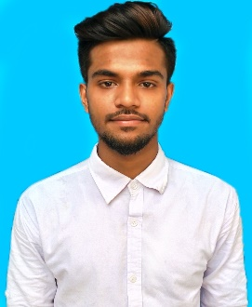

**LANGUAGE PROFICIENCY**

English: Intermediate/Advance.

Bangla: Intermediate/Communicational/Advance.

**PERSONAL INFORMATION**

Date of Birth : 5 October 2000

Present Address : Village - Nagar Konda, Post office-

Konda Bazar , Savar,Dhaka

NID NO : 9161936860

**EDUCATION**

**Diploma In Engineering**

Govt. Graphic Arts Institute

Major : Computer Science & Technology

Passing Year : 2023

CGPA : Not Yet

Board : Dhaka

**Secondary School Certificate (SSC)**

Konda High School and Collage

Group : Building Maintenance

Passing Year : 2017

GPA : 4.57

Board : Dhaka

**TRAINING & CERTIFICATIONS**

**Creative IT Institute** (Intern)

Professional Web Design

Oct 2022 – Jan 2023

**Digital Scholar**

Graphic Design

April 2021 – Aug 2021

**SKILLS**

**HARD SKILL**

* HTML5, CSS3, Bootstrap, JavaScript basic, jQuery
* Basic Adobe Photoshop
* MS Word, PowerPoint, Excel

**SOFT SKILL**

* Communication
* Organization
* Team Management

**RAKIB SIDDIKI**

**Web Designer**

Contact No: 01768440404

E-mail: rmrakib901@gmail.com

Address: Nagar Konda, Savar, Dhaka

Portfolio:

**WORK EXPERIENCE**

**Mobile Game & Application Project, ICT**

UI UX Designer (Team Work)

**CAREER OBJECTIVES**

As a web designer, my objective is to make a positive impact on clients, co-workers, and the Internet using my skills and experience to design compelling and attractive websites. Solving code problems. Learning new codes and methods for better work experience.